# WEB APPLICATION PENETRATION TESTING

**Prepared By: Vishal sanjay patil**

**Email:pvishu570@gmail.com**

**Report Date: 21/08/2024**

## Task Level: Hard

**Intern ID :CT3MTDS059**



# Table of contents

**1. Introduction:**

* Purpose of the Assessment
* Objectives
* Scope
* Methodology

**2. Attack Initiation:** - **Reconnaissance**

* -Tools Used
* -Findings

- **Scanning**

* Tools Used
* Scan Results

− Vulnerability Assessment

* Tools Used
* Scan Results

- **Exploitation**

* Techniques Used
* Exploited Vulnerabilities

**3. Conclusion:**

* Summary of Findings
* Recommendations

**Introduction:**

The objective of this report is to conduct a vulnerability assessment on the website http://testphp.vulnweb.com/ and outline an attack plan to demonstrate potential security risks. The assessment will involve identifying and analyzing vulnerabilities within the website's structure, functionalities, and configurations.

**Purpose:**

I want to find vulnerabilities in http://testphp.vulnweb.com/ to help make it more secure and protect it from cyber threats.

**Methodology:**

## Information Gathering

* Identifying the web server technology and version.
* Enumerating the website's directories and files.

## Planning

* Prioritizing potential attack vectors based on their severity and impact.
* Selecting appropriate tools and techniques for each attack.
* Defining the scope and objectives of the assessment.

## Vulnerability Assessment Penetration testing

* Findings vulnerablities
* Exploting vulnerability

## Analysis and Recommendations

* Documentation of vulnerabilities exploited and their potential impact.
* Recommendations for remediation, including patching vulnerable code, implementing input validation, and conducting regular security assessments.
* Suggestions for improving the overall security posture of the website

**Information Gathering:**

**Target Website Information**

**Link: http://testphp.vulnweb.com/**

**IpAddress: 44.228.249.3**

**Tools Used**

Maltigo (information-gathering tool)

**Site Used**

www.who.is (information gathering site )

## Results

**Hostname**   **Type TTL**

Testphp.vulnweb.com SOA 1800

**Content** ns1.eurodns.com hostmaster@eurodns.com 2021110100 86400 7200 604800 86400

**Registar :**

Eurodns S.A. EuroDNS S.A.

IANA ID: 1052

URL: http://www.eurodns.com.http://www.EuroDNS.com Whois Server: whois.eurodns.com legalservices@eurodns.com

(p) +352.27220150

**Domain Name**: VULNWEB.COM

**Registry Domain ID**: D16000066-COM

**Registrant Name:** Acunetix Acunetix

**Registrant Organization:** Acunetix Ltd

**Registrant Street**: 3rd Floor,, J&C Building, Road Town

**Registrant City:** Tortola

R**egistrant Country**: VG

**Registrant Phone:** +1.23456789

**Registrant Email**: administrator@acunetix.com

**Registry Admin ID:** Admin Name: Acunetix Acunetix

**Admin Organization:** Acunetix Ltd

**Admin Street:** 3rd Floor,, J&C Building, Road Town

**Admin City:** Tortola

**Admin Country:** VG

**Admin Phone:** +1.23456789

**Admin Email:** administrator@acunetix.com

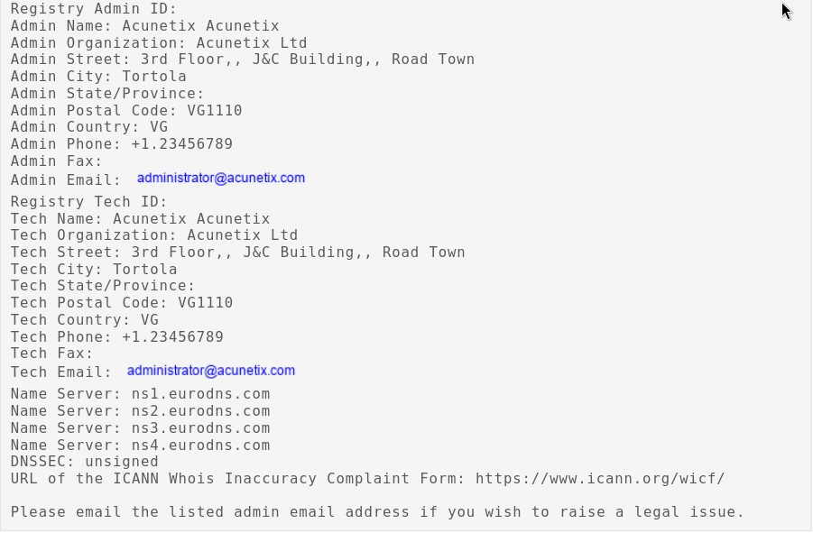

## Scanning

* **Link: http://testphp.vulnweb.com/**
* **IpAddress: 44.228.249.3**

### Tools Used

* Nmap(port scanning)
* Legion (scanning )
* Dirb (directory finder)



### Scan Results

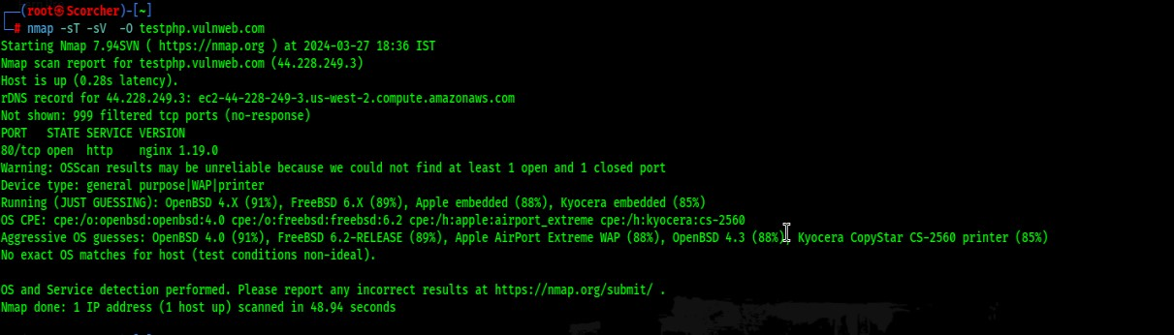

**Command Used: nmap -sT -sV –O testphp.vulnweb.com**

* **Port : 80 Open**
* **Service: http**
* **Version: nginx 1.19.0**
* **Operating system: Linux 3.11 -4.1**

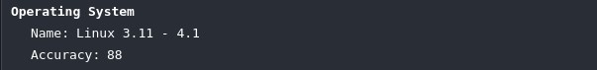

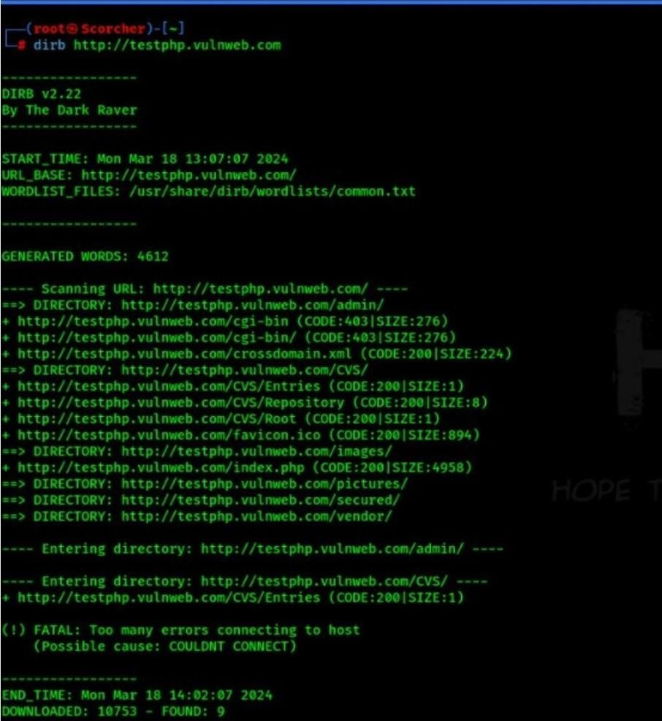

**Command Used dirb http://testphp.vulnweb.com**

**Directories Found:**

http://testphp.vulnweb.com/ http://testphp.vulnweb.com/admin/ http://testphp.vulnweb.com/CVS/ http://testphp.vulnweb.com/inages/ http://testphp.vulnweb.com/pictures/ http://testphp.vulnweb.com/secured/ http://testphp.vulnweb.com/vendor/ http://testphp.vulnweb.com/CVS/Entries

## Vulnerability Assessment

* **Link: http://testphp.vulnweb.com/**
* **IpAddress: 44.228.249.3**

**Tools Used**

* Owasp Zap (vulnerability scanner)

### Scan Results

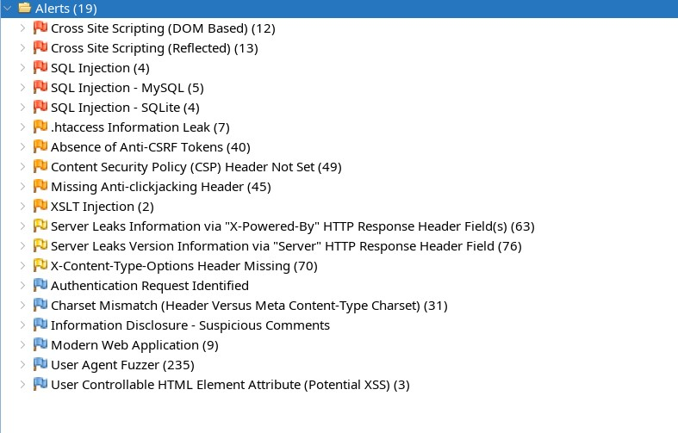

**Risk levels**

Included: High, Medium, Low, Informational

Excluded: None

**Confidence levels**

Included: User Confirmed, High, Medium, Low

Excluded: User Confirmed, High, Medium, Low, False Positive

### Summaries

**Alert counts by risk and confidence**

This table shows the number of alerts for each level of risk and confidence included in the report.

(The percentages in brackets represent the count as a percentage of the total number of alerts included in the report, rounded to one decimal place.)

|  |  |  |  |  |  |  |
| --- | --- | --- | --- | --- | --- | --- |
|  |  | **User Confirmed** | **High** | **Confidence** | | **Total** |
| **Medium** | **Low** |
| **R is k** | **High**  **Medium**  **Low Informati onal** | 0 (0.0%)  0  (0.0%)  0 (0.0%)  0  (0.0%) | 1 (5.0%)  1  (5.0%)  1 (5.0%)  1  (5.0%) | 4 (20.0%)  3 (15.0%)  2 (10.0%)  2  (10.0%) | 0 (0.0%)  1  (5.0%)  0 (0.0%)  4  (20.0%) | 5 (25.0%)  5 (25.0%)  3 (15.0%)  7  (35.0%) |
|  |  |  |  |  |  |  |
|  | **Total** | 0 (0.0%) | 4 (20.0%) | 11 (55.0%) | 5 (25.0%) | 20 (100%) |

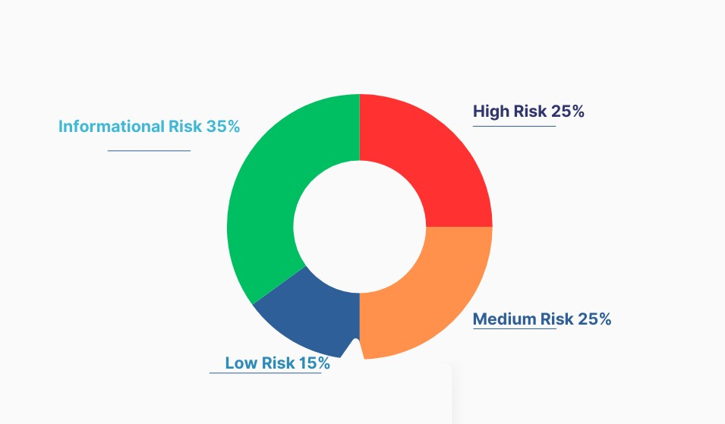

**Alert counts by site and risk**

This table shows, for each site for which one or more alerts were raised, the number of alerts raised at each risk level.

Alerts with a confidence level of "False Positive" have been excluded from these counts.

(The numbers in brackets are the number of alerts raised for the site at or above that risk level.)

**Risk**

**Informational**

**High** **Medium** **Low** **(>=**

**(= High) (>= Medium) (>= Low) Informational**

**)**

**http://testphp.vulnwe** 5 5 3 7

**= b.com** (5) (10) (13) (20)

#### Alert counts by alert type

This table shows the number of alerts of each alert type, together with the alert type's risk level. (The percentages in brackets represent each count as a percentage, rounded to one decimal place, of the total number of alerts included in this report.)

**Alert type Risk Count**

**Cross Site Scripting (DOM Based)** High 12

**Cross Site Scripting (Reflected)** High 13

**SQL Injection** High 4

**SQL Injection - MySQL** High 5

**SQL Injection - SQLite** High 4

**.htaccess Information Leak** Medium 7

**Absence of Anti-CSRF Tokens** Medium 45

**Content Security Policy (CSP) Header Not Set** Medium 51

**Missing Anti-clickjacking Header** Medium 47

**XSLT Injection** Medium 2

**Server Leaks Information via "X-Powered-By" HTTP Response**

**Header Field(s)** Low 63

**Server Leaks Version Information via "Server" HTTP Response**

**Header Field** Low 76

**X-Content-Type-Options Header Missing** Low 72

**Authentication Request Identified** Informat 1

ional

**Charset Mismatch (Header Versus Meta Content-Type Charset)** Informat 34

ional

**Information Disclosure - Suspicious Comments** Informat 1

ional

|  |  |  |
| --- | --- | --- |
| **Modern Web Application** | Informat ional | 9 |
| **Session Management Response Identified** | Informat ional | 4 |
| **User Agent Fuzzer** | Informat ional | 235 |
| **User Controllable HTML Element Attribute (Potential XSS)** | Informat ional | 10 |
| **Total Vulnerability Found** |  | 20 |

**Exploitation**

**Exploited Vulnerabilities:**

* Cross Site Scripting (Reflected)
* Cross Site Scripting (DOM Based)
* SQL Injection
* Absence of Anti-CSRF Tokens
* Missing Anti-clickjacking Header

### Cross Site Scripting (Reflected)

Reflected cross-site scripting (XSS), also known as **non-persistent XSS*, occurs when a malicious script is reflected off a web application and executed in the victim's browser. Let's delve into the details:

* Reflected XSS arises when an application receives data in an *HTTP request* (usually from a URL parameter) and includes that data in the immediate response *without proper sanitization*.
* Imagine a website with a search function that echoes the user-supplied search term in the response.

For instance:

* User searches for "gift": https://insecure-website.com/search?term=gift
* Response: <p>You searched for: gift</p>
* An attacker can construct a malicious URL like this:
* https://insecure-website.com/search?term=<script>/* Bad stuff here... */</script>
* Resulting response: <p>You searched for: <script>/* Bad stuff here... */</script></p>
* If another user visits the attacker's URL, the injected script executes in their browser, compromising their session with the application.

* When an attacker controls a script executed in the victim's browser, they can:
* Perform actions within the application.
* View information accessible to the user.
* Modify user data.
* Initiate interactions with other users, appearing to originate from the victim.
* Delivery mechanisms include links on attacker-controlled websites, emails, tweets, or messages. - Unlike stored XSS, where self-contained attacks occur within the application, reflected XSS relies on external delivery.

* The location of reflected data in the application's response determines the payload needed to exploit it.
* Varieties include:
* HTML context*: Payloads directly affect the DOM.
* JavaScript context*: Payloads execute as JavaScript code.
* URL context*: Payloads manipulate URLs.
* Other contexts*: Payloads adapt to specific situations.

.

### • Open website • Type Java Script search bar • press search button

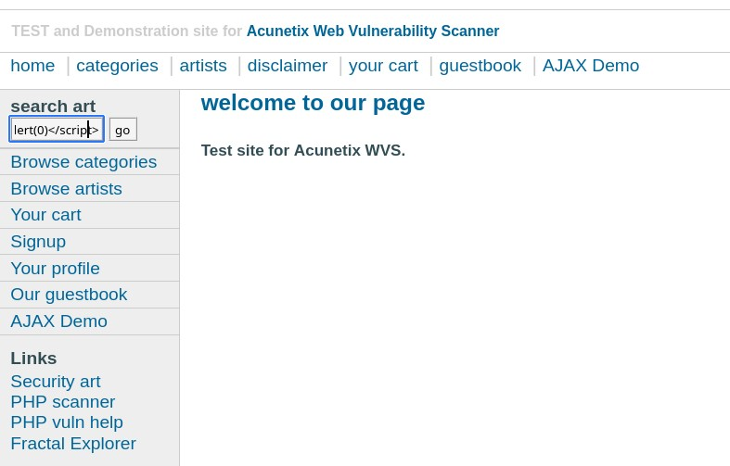

**Command Used <script>alert(0)</script>**

**Result**

### • Popup appears

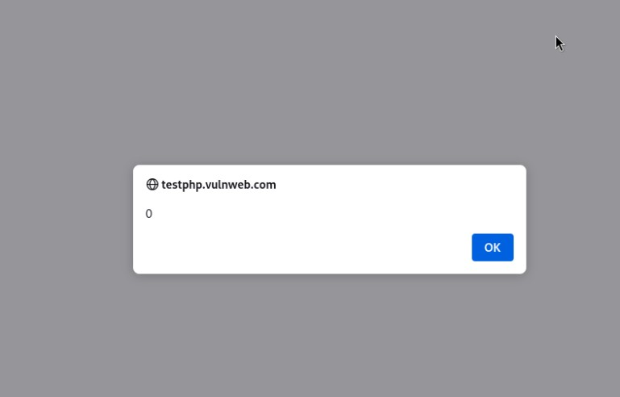

### Cross Site Scripting (DOM Based)

DOM-based cross-site scripting (DOM XSS)* is a type of *cross-site scripting (XSS)* attack that occurs when malicious code is executed by manipulating the *Document Object Model (DOM)* in a victim's browser. Let's break it down:

* DOM-based XSS vulnerabilities typically arise when JavaScript takes data from an *attacker-controllable source, such as the URL, and passes it to a **sink* that supports dynamic code execution (e.g., eval() or innerHTML).
* Attackers exploit this by injecting malicious JavaScript, which can lead to account hijacking or other security breaches.
* To execute a DOM-based XSS attack, the attacker places data into a source (often the URL) so that it propagates to a sink, causing arbitrary JavaScript execution.

* Sources: Common sources for DOM XSS include the URL (accessed via window.location) and other parts of the page (e.g., query strings or fragments).
* Sinks: These are places where JavaScript execution occurs, such as attributes, innerHTML, or other dynamic content.

* Login into site
* Open profile section
* Type Java Script code in name section
* Press update button

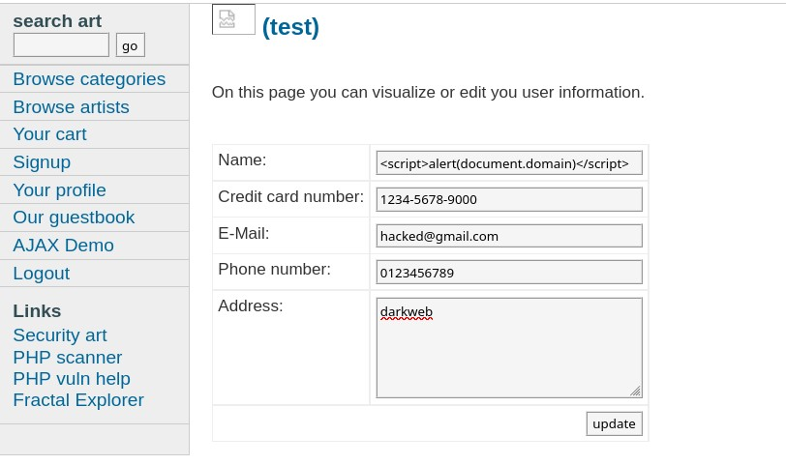

Command Used <script >alert(document.domain)</script>

#### • Result: Popup appears

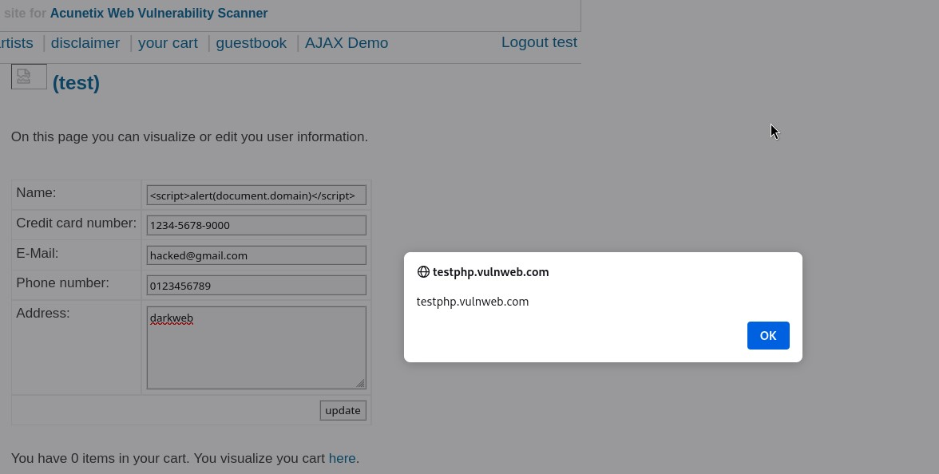

## SQL Injection

SQL injection (SQLi) is a web security vulnerability that allows an attacker to manipulate the queries an application makes to its database. Here's what you need to know:

* SQL injection occurs when an attacker inserts *malicious SQL statements* into an application's input fields.
* These statements can alter the intended behavior of the application and interact with the database in unintended ways.
* The attacker can view, modify, or delete data they wouldn't normally have access to.
* In severe cases, SQL injection can lead to server compromise or denial-of-service attacks.

* Unauthorized access to sensitive data, including:
* *Passwords*
* *Credit card details*
* *Personal user information*
* High-profile data breaches have occurred due to SQL injection, resulting in reputational damage and regulatory fines.
* In some cases, attackers establish a *persistent backdoor* into an organization's systems, going unnoticed for extended periods.

* Manual testing against every entry point in the application:
* Submit the single quote character ' and look for errors or anomalies.
* Use SQL-specific syntax to evaluate base values and different values, observing application responses.
* Test boolean conditions like OR 1=1 and OR 1=2.
* Check for time delays triggered by specific payloads within SQL queries.
* Monitor out-of-band network interactions caused by OAST payloads. - Alternatively, use *Burp Scanner* for efficient detection.

* Open terminal in kali linux
* Open sqlmap tool for attack

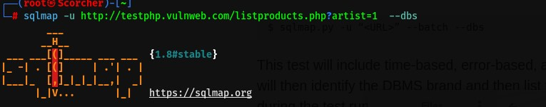

Command Used : sqlmap –u http://testphp.vulnweb.com/listproducts.php?artists=1 --dbs

|  |  |
| --- | --- |
| sqlmap | To Open tool |
| -u | Set target |
| --dbs | Search database |

Result : 2 tables found

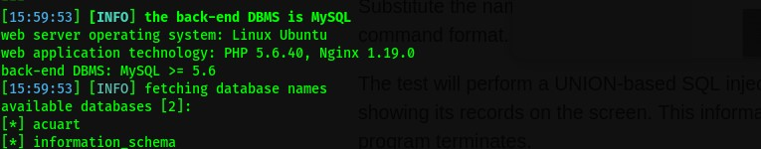

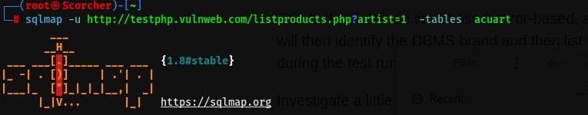

Command Used : sqlmap –u http://testphp.vulnweb.com/listproducts.php?artists=1 -tables acuart

|  |  |
| --- | --- |
| -tables | To select tables from database |

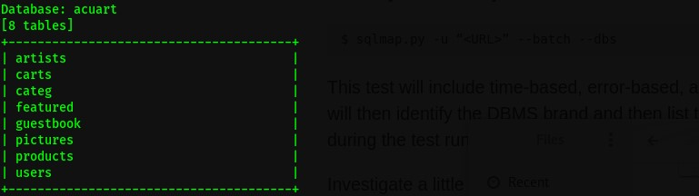

Result: 8 tables found

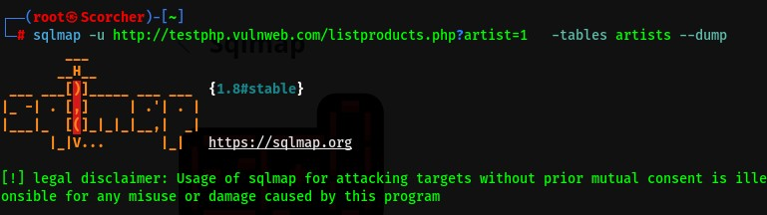

Command Used sqlmap –u http://testphp.vulnweb.com/listproducts.php?artists=1 -tables artists -dump

|  |  |
| --- | --- |
| --dump | To dump add data from selected table |

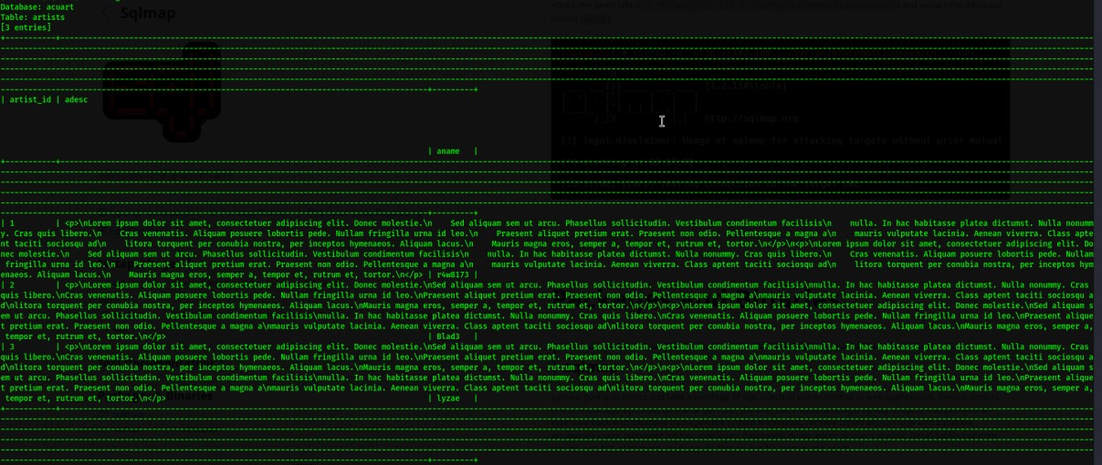

Result: 3 artists found

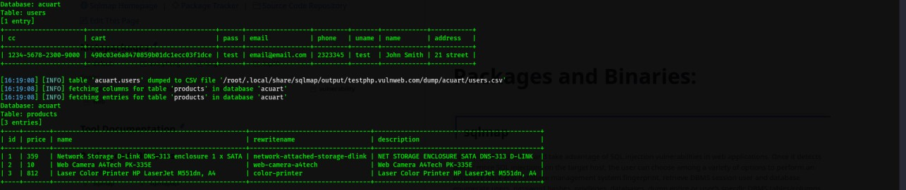

Result: 1 user found

Result: 3 products found

|  |  |
| --- | --- |
| cc | 1234-5678-2300-9000 |
| cart | 490c03e6a8470859b01dc1ecc03f1dce |
| pass | test |
| email | Email@email.com |
| phone | 2323345 |
| uname | test |
| name | John smith |
| address | 21 street |

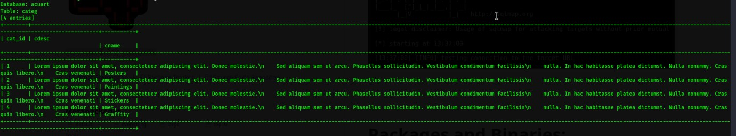

Result: 4 categ found

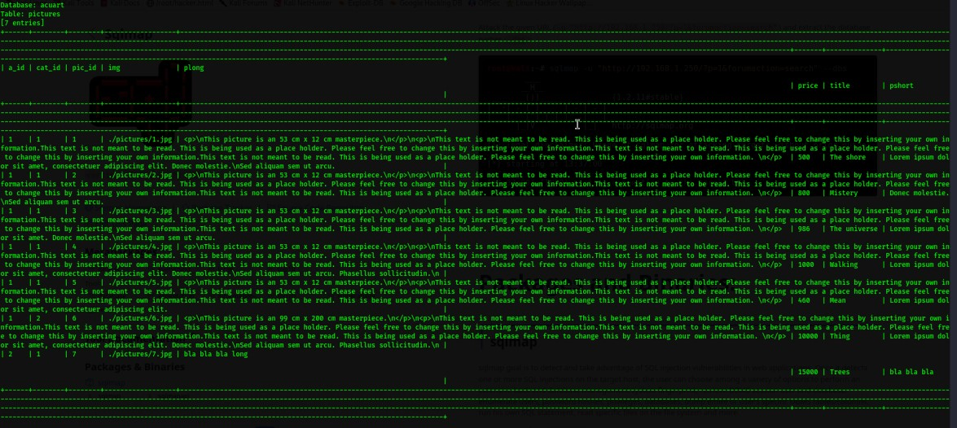

Result: 9 pitctures found

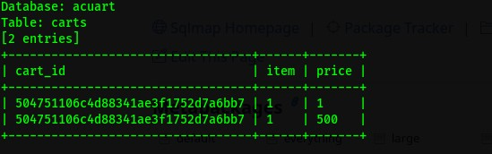

Result:2 cart items found

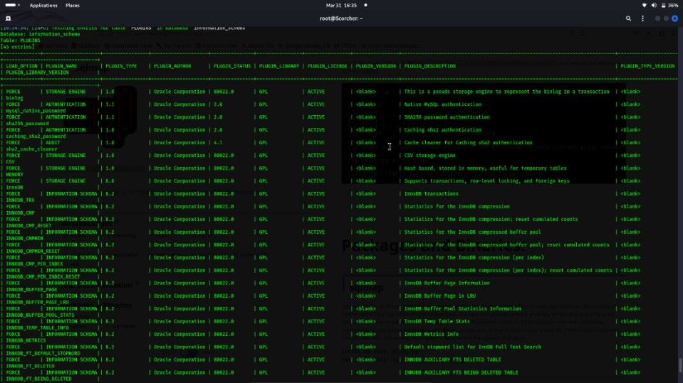

Result: server processlist found

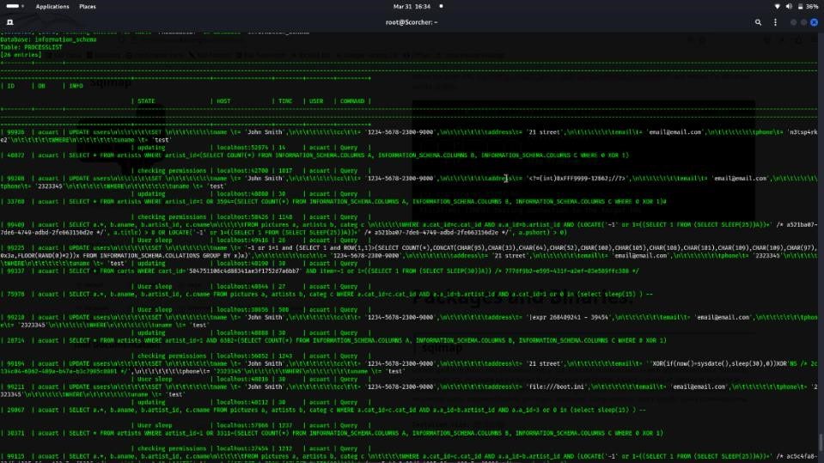

Result: Server plugin found

## CSRF

Cross-Site Request Forgery (CSRF) is a type of security vulnerability that occurs when an attacker tricks a user into unintentionally performing actions on a website where they are authenticated. This attack takes advantage of the trust a website has in a user's browser

**Authentication:** The user logs into a website and obtains a session cookie, which authenticates them to perform actions on the site.

**Malicious Link:** The attacker creates a malicious link (often disguised as something innocent, like a button) and sends it to the victim. When the victim clicks on the link while still logged into the target website, the browser automatically sends any associated cookies along with the request.

**Unauthorized Action:** The malicious link triggers a request to the target website, causing the user's browser to execute an action (e.g., changing the user's email, transferring funds, etc.) on behalf of the authenticated user.

**Impact:** Since the request originates from the user's browser with valid authentication credentials, the target website processes it as a legitimate request. This allows the attacker to perform actions without the user's knowledge or consent.

CSRF vulnerabilities can be particularly dangerous because they exploit the trust between a user and a website. However, implementing proper defenses such as CSRF tokens can mitigate this risk.

A CSRF token is a unique value generated by the server and included in each form or request. The token is typically stored in a hidden field or in an HTTP header. When the user submits a form or makes a request, the server verifies that the token matches the expected value associated with the user's session. If the token is missing or incorrect, the server rejects the request, preventing CSRF attacks.

* Open website
* Righclick on page and opn view page source
* Copy the login form
* Pest into in noepad
* Modify that form by adding some lines of code for changinig name(hide the form , auto submit form)
* Embed into another site
* Send that like to victim
* After victim click submit button from that link their username will change

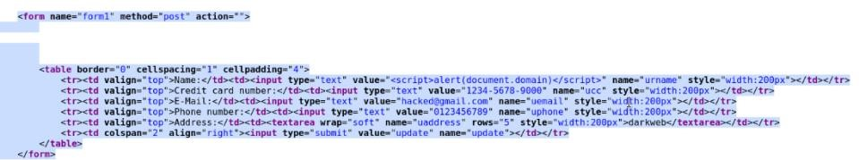

Original code

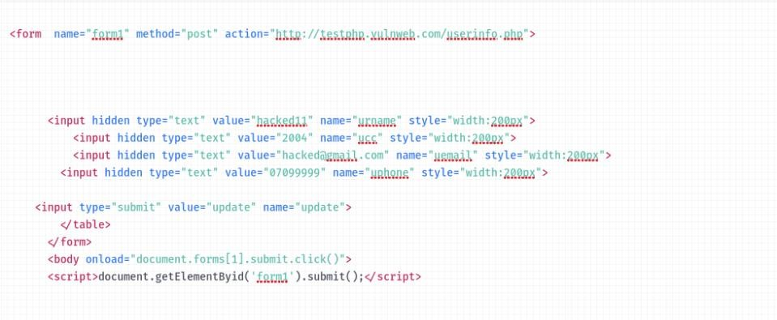

Modifyed code

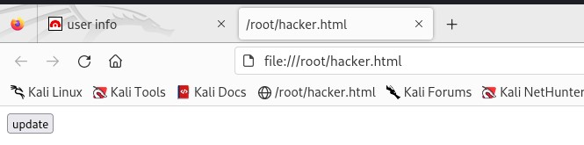

Link which sends to victim

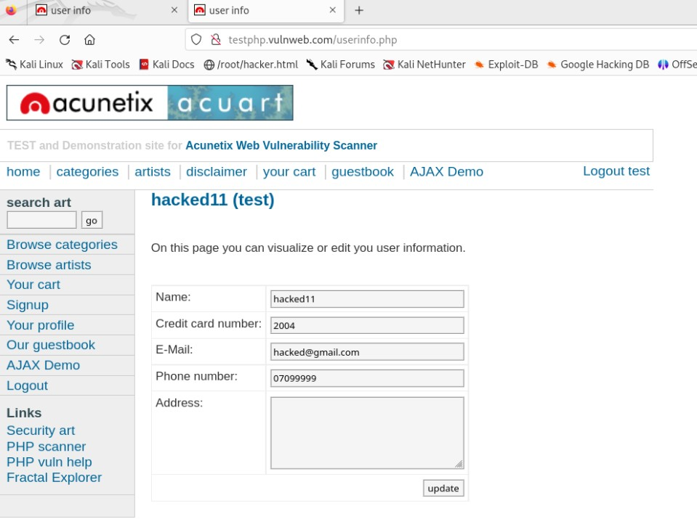

Result : Name changed

## Missing Anti-clickjacking Header

The "Missing Anti-clickjacking Header" vulnerability refers to a security weakness in web applications where proper protection against clickjacking attacks is not implemented. Clickjacking is a type of attack where an attacker tricks a user into clicking on something different from what the user perceives, often by overlaying malicious content on top of legitimate web pages.

* Open burpsuit
* Select burp click bandit from right corner
* Copy the code
* Open browser and go to 3 dots and developer tools and pest thet code into console
* Click the start button then click the target button to click
* Click the finish button
* And save the file

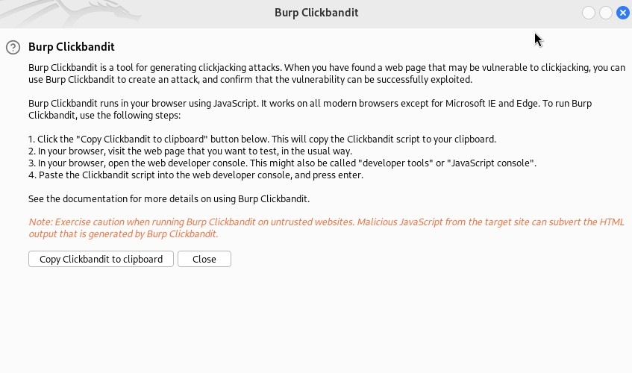

Copy this code

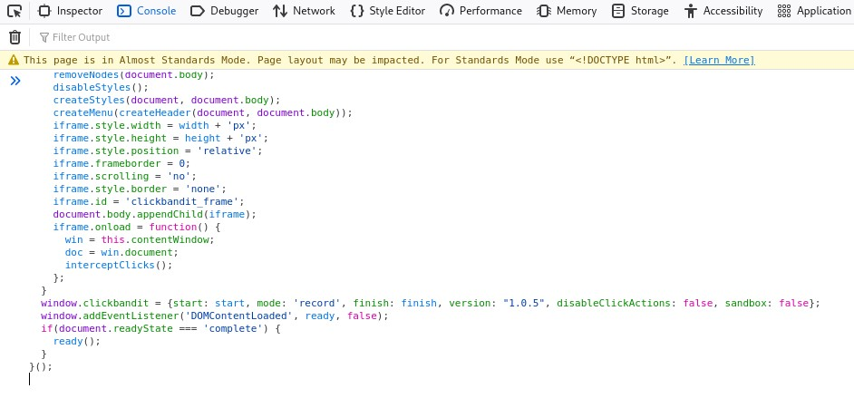

Pest into developer console

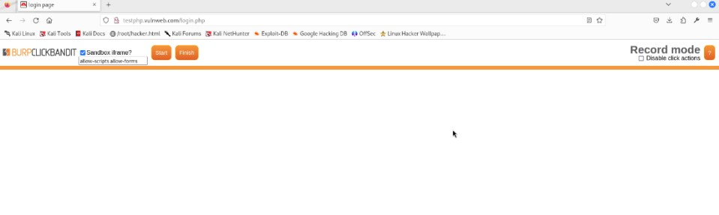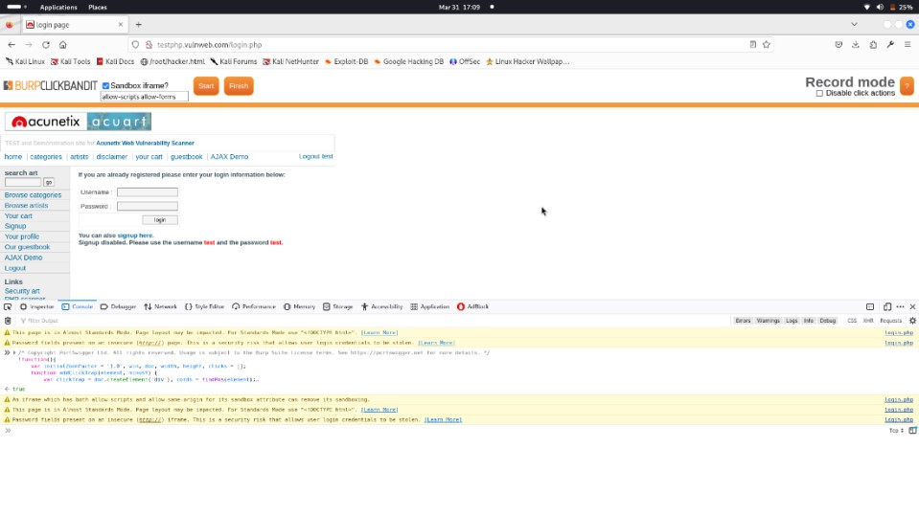

Select the target button to click

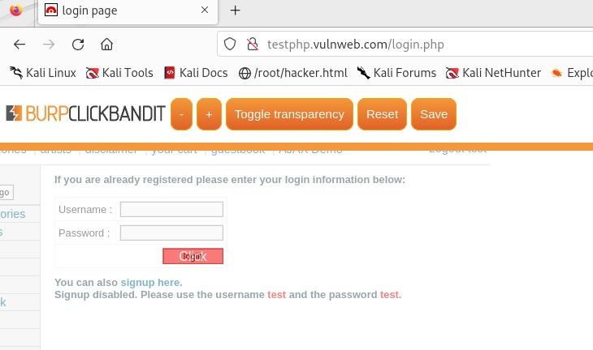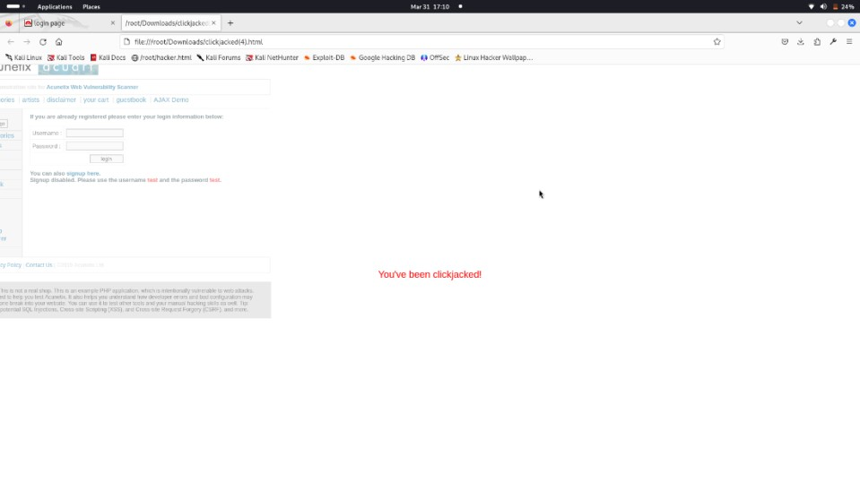

When victim click on our target button poup appears

**Conclusion:**

* Summary of Findings
* Mitigations

**Cross Site Scripting (Reflected):**

Summary:

Cross-Site Scripting (XSS) occurs when an attacker injects malicious scripts into web pages viewed by other users. In reflected XSS, the malicious script is reflected off a web server, such as in an error message or input field, and executed when the victim visits a specially crafted link.

Mitigation Methods:

1. Input Validation and Sanitization: Validate and sanitize user inputs to remove or encode any potentially harmful characters before processing them.
2. Output Encoding: Encode output to prevent script execution. HTML-encode dynamic content before rendering it in the browser to neutralize any injected scripts.
3. Content Security Policy (CSP): Implement CSP headers to restrict which resources can be loaded, reducing the risk of XSS attacks by specifying trusted sources for scripts, stylesheets, images, etc.

**Cross Site Scripting (DOM Based):**

Summary:

DOM-Based XSS is a type of XSS attack where the vulnerability exists in client-side JavaScript code rather than server-side code. The malicious payload is processed by the client's browser, manipulating the Document Object Model (DOM) to execute the attack.

Mitigation Methods:

1. Client-Side Input Validation: Sanitize and validate all inputs on the client side to prevent malicious input from being processed by JavaScript code.
2. Safe DOM Manipulation: Avoid using unsanitized user input in JavaScript code that directly manipulates the DOM. Use safe methods for DOM manipulation and avoid using `innerHTML` or `eval()` functions with user-controlled data.
3. Strict Output Encoding: Apply strict output encoding to all dynamic content rendered by

JavaScript to prevent XSS vulnerabilities from being introduced through client-side code execution.

**SQL Injection:**

Summary:

SQL Injection is a code injection technique that exploits vulnerabilities in database queries. Attackers inject malicious SQL queries through user inputs to manipulate the database or gain unauthorized access.

Mitigation Methods:

1. Parameterized Queries: Use parameterized queries or prepared statements provided by your database framework to separate SQL code from data, preventing injection attacks.
2. Input Sanitization: Sanitize user inputs by removing or escaping special characters that could alter the SQL query structure. Use whitelisting rather than blacklisting approaches to validate inputs.

3.Least Privilege Access Control: Enforce least privilege access control to databases by restricting database user permissions to only necessary operations, reducing the impact of successful SQL injection attacks.

These mitigation methods help in mitigating the risks associated with each vulnerability, strengthening the security posture of web applications.